|  |
| --- |
| OBJECTIVES |
| 1. What is Software? 2. What is System software? 3. Type of System Software? 4. Features of System Software? |

PROCESDURE

* Task 1: **What is Software?**

Software is the collection of data, programs, procedures, routines and instructions that tell a computer or electronic device how to run, work and execute specific tasks. This is in contrast to hardware, which is the physical system and components that perform the work.

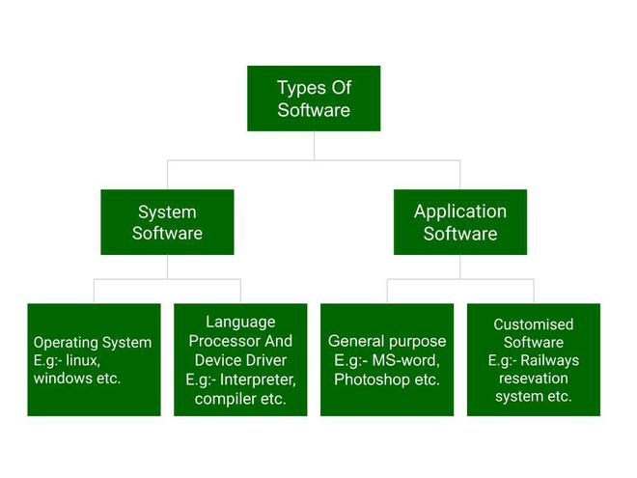

* Task 2: **What is system software?**

System software is software that directly operates the computer hardware and provides the basic functionality to the users as well as to the other software to operate smoothly. Or in other words, system software basically controls a computer’s internal functioning and also controls hardware devices such as monitors, printers, and storage devices, etc.

* Task 3: Type of System Software?

It has two subtypes which are:

* **Operating System** It is the main program of a computer system. When the computer system ON it is the first software that loads into the computer’s memory. Basically, it manages all the resources such as memory, CPU, printer, hard disk, etc., and provides an interface to the user, which helps the user to interact with the computer system. It also provides various services to other computer software. Examples of operating systems are Linux, Apple macOS, Microsoft Windows, etc.

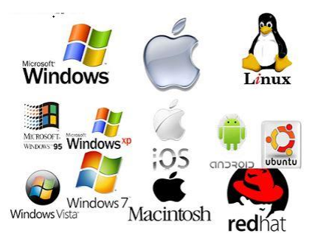

* **Language Processor** As we know that system software converts the human-readable language into a machine language and vice versa. So, the conversion is done by the language processor. It converts programs written in high-level programming languages like Java, C, C++, Python, etc. (known as source code), into sets of instructions that are easily readable by machines (known as object code or machine code).
* **Device Driver** A device driver is a program or software that controls a device and helps that device to perform its functions. Every device like a printer, mouse, modem, etc. needs a driver to connect with the computer system eternally. So, when you connect a new device with your computer system, first you need to install the driver of that device so that your operating system knows how to control or manage that device.
* Task 4: Features of System Software.

Let us discuss some of the feature of System Software:

* System Software is closer to the computer system.
* System Software is written in a low-level language in general.
* System Software is difficult to design and understand.
* System Software is fast in speed (working speed).
* System Software is less interactive for the users in comparison to application software.